Ba’moor
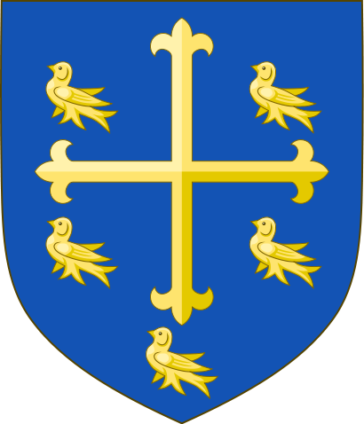
Destiny By Our Hand

Ours is a world of beauty and grace; a vision of divine tranquillity and perfection manifest in the sprawling miracle of creation. And yet, this world is beset by one weakness, a corruption that infests every strand of the tapestry of life. That weakness is man. Infesting the land like a plague with his vice, celebrating his own foulness in sprawling cities of iniquity, and revelling in the base desires of the flesh. At his worst, man is no more than a vessel for his lust, greed, and avarice.
Thankfully, the all-seeing creator has sent forth to us a mighty message to save the world of man from such depravity and exalt the greatest of his virtues. That message is war, and, and we are its messengers.

The Lands of Ba’moor
The folk of Ba’moor are a hardy and resilient people, well suited to life on the harsh climbs of the Mazarane Steppe, which leads up to the Drith’Riems Plateau, where once nomadic tribes would herd animals and chase the seasons. The grasslands have since been turned to farming, watched over by the stone keeps and guard towers of the Ba’moor lords.
Running through these lands is the great Atray River, descending from the Mazarane and heading east toward the Suffering Sea on the other side of Bara’ghost, it passes through the Lost City of Seragol and runs in parallel to the Great Road which leads to the Salvation Walls largest gate. The river once served as a vital conduit for Ba’moor trade across the kingdoms and while the deep fast moving waters are still rich in fresh fish, the dead forests have made it unusable beyond the great wall.

The City of Damietta
Situated at the foot of the Mazarane, the city of Damietta stands on a high rock island in the centre of the Atray. With the thundering waterfall of the mountain river at its back and the fast moving currents, Damietta is connected to the north and south shores by two mighty bridges, named Osric and Welden, after the first great kings of the Ba’moor. More of a fortress than a city, the high stone walls of Damietta defend the throne of King Osric VII, Master of War and Conqueror of the Untamed.
Amida
Tancred of Amida has been dead many years, though the great stone walls of his castle still stand as a testimony to his legend. On the far borders of Ba’moor, Amida stands sentinel, eyes ever fixed upon the great wall. With a double curtain wall and sturdy Ba’moorian keep, Amida rests upon a raised outcrop of bedrock upon the open plains, and is second only to Damietta in its impregnability. Amida is currently the seat of Lord Aldwyn the Dauntless, of House Brennus.

The Houses of Ba’moor
The king himself cannot hope to govern and defend the people of Ba’moor alone, and is advised and supported by the seven House lords of the realm. Each lord is sworn to his king, not only to serve, but to ensure the fidelity of the king to the dictates of the Ba’moor creed. These oaths bind not only the lords to their king, but to each other. The king himself acts most commonly as arbitrator between his council and dispenser of royal justice, maintaining unity between his lords and allowing them to govern the lands of the Ba’moor in his name. In this regards, the greatest of kings have most often been the wisest, and yet, wisdom for the Ba’moor comes only from experience and valour, and it is the king to whom the lords turn to lead their armies in times of war.

House Ortiagon
Lord: Selwyn, The Undying
Notes: The crippled lord, survivor of a hundred wounds

House Dumnorix
Lady: Nelda, The Orphaned
Notes: Last of a line murdered by treachery, consummate diplomat

House Caros
Lord: Eldred, The Bold
Notes: The young master, ambitious and brave

House Sinatus
Lord: Byron, The Sage
Notes: The wisest lord alive or dead, master strategist

House Leukon
Lady: Arlyss, The Just
Notes: Keeper of laws, morality and the Creed personified

House Ambon
Lady: Kendra, The Warmaid
Notes: Forever abroad, relentless warrior

House Brennus
Lord: Aldwyn, The Dauntless
Notes: Uncompromising and Stalwart, watcher and defender

The Creed
Ba’moorian society is governed by one overriding ethos; that one’s destiny is shaped by his or actions, not by fate or the divine. War has come to hold a near religious importance to the Ba’moor, even more so in the generations following the great exodus, and forms a central theme of their culture. To wage war is to forge the destiny of the people; it brings out the best traits in humanity, as well as the worst. It is these positive traits; sacrifice; mercy; loyalty; and bravery, that the Ba’moor seek to achieve. In its simplest form, to wage the perfect war is to improve the soul of man, to attain something near to the great perfection that is creation itself. Unlike many other warlike peoples, however, the Ba’moor consider war itself in a collective sense; deeds of personal glory are only celebrated for what they can teach others, and victory is always claimed in the name of the people, not the person. Deed names are common among the Ba’moor, as each name is a lesson for others to observe. Similarly, those transgressing the Creed are often given Shame names, such as ‘the unjust’ or ‘the liar’ or ‘the coward’.
While the interpretation of the Creed has been the philosophical interest of countless scholars for generations, the enforcement of the Creed and maintaining its adherence is the task of the king, his justice being dispensed through his lords, their castellans and sheriffs across the realm. That is not to say that the men and women of Ba’moor are incapable of treachery, cowardice or greed. The lords of Ba’moor know only too well the natural weakness within mankind, and enforce the Creed with harsh judgement throughout the realm. Of all the Five Kingdoms, Ba’moor justice is the most swift and unflinching. For the common man or woman in Ba’moor, the Creed is also a set of moral values and exemplars, a series of higher goals to achieve in life before the soul returns to creation upon death.
Look and feel is very simple for the Ba’moorians. Due to their obsessive interest in battle and war they have a very traditional look to going to war. Long swords, pikes, Norman shields, archers, spears and other weapons of mass war. Armour is also very simple, heavy chain for infantry with tabards of their houses, kettle or pot helms for their soldiers and Long and short bows with heavy leather for their archers. Ba’moor is war!

All you need to do if you wish to play a son of Ba’moor is make every effort to look the part, choose a house then join the adventure.

